Linux Basics — DevOps Assignment
Name: Zaher Khan
GitHub Repository: https://github.com/Zashohub/Zaher-Linux-assessments

Objective
Practise essential Linux command-line operations — file and directory management, viewing files, searching, archiving, downloading, permissions, and environment variables.

1. Creating and Renaming Files/Directories
- Create a directory named test_dir using mkdir.
- Inside test_dir, create an empty file called example.txt.
- Rename example.txt to renamed_example.txt using mv.
Commands & Explanation:
1} I instantiated the test_dir directory by executing mkdir test_dir. This command invokes the make-directory utility, allocating a new inode and establishing a structured subdirectory within my active filesystem hierarchy.
2} I initialized the blank example.txt file inside test_dir by executing touch test_dir/example.txt. This utility generates an empty zero-byte file object and registers a corresponding inode within the subdirectory.
3} I initialized the blank example.txt file inside test_dir by executing touch test_dir/example.txt. This utility generates an empty zero-byte file object and registers a corresponding inode within the subdirectory.
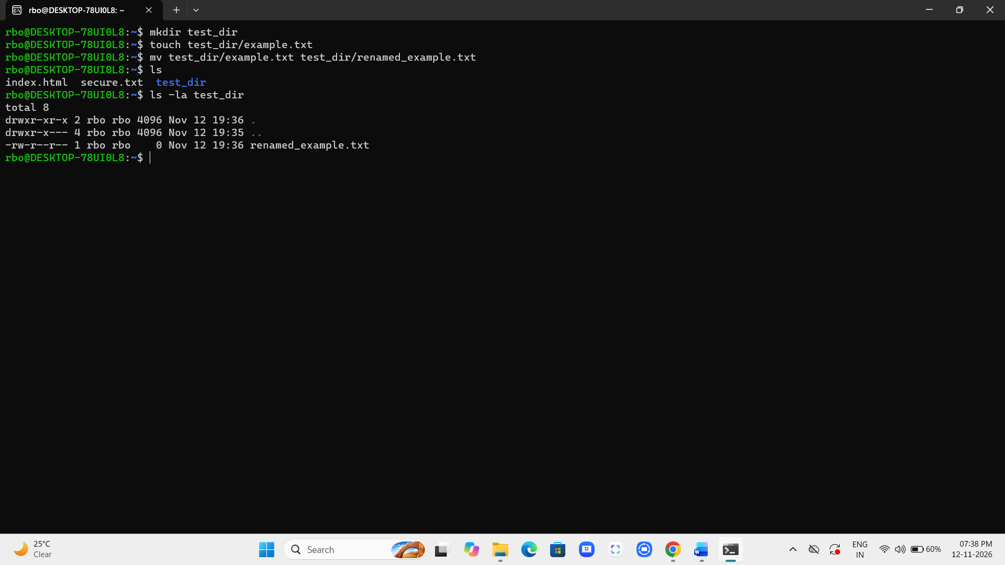

2. Viewing File Contents
- Use cat to display the contents of /etc/passwd.
- Display only the first 5 lines of /etc/passwd using head.
- Display only the last 5 lines of /etc/passwd using tail.
Commands & Explanation:
1} I displayed the complete contents of /etc/passwd by executing cat /etc/passwd. The concatenate utility reads the sequential byte stream and renders all system user account entries directly to standard output.
2} I retrieved the initial five lines of /etc/passwd by executing head -n 5 /etc/passwd. This filter intercepts the file stream and isolates the top records while truncating subsequent system output.
3} I inspected the final five lines of /etc/passwd by executing tail -n 5 /etc/passwd. This utility seeks the end-of-file marker and renders only the most recently appended account entries.

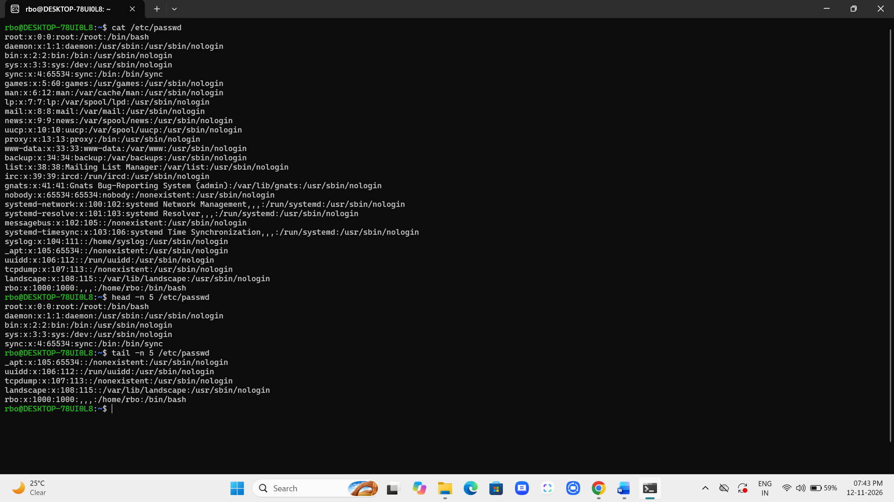

3. Searching for Patterns
- Use grep to find all lines containing the word “root” in /etc/passwd.
Commands & Explanation: I isolated every entry containing the string "root" by executing grep "root" /etc/passwd. This pattern-matching utility parses the user database line by line and prints matching records.

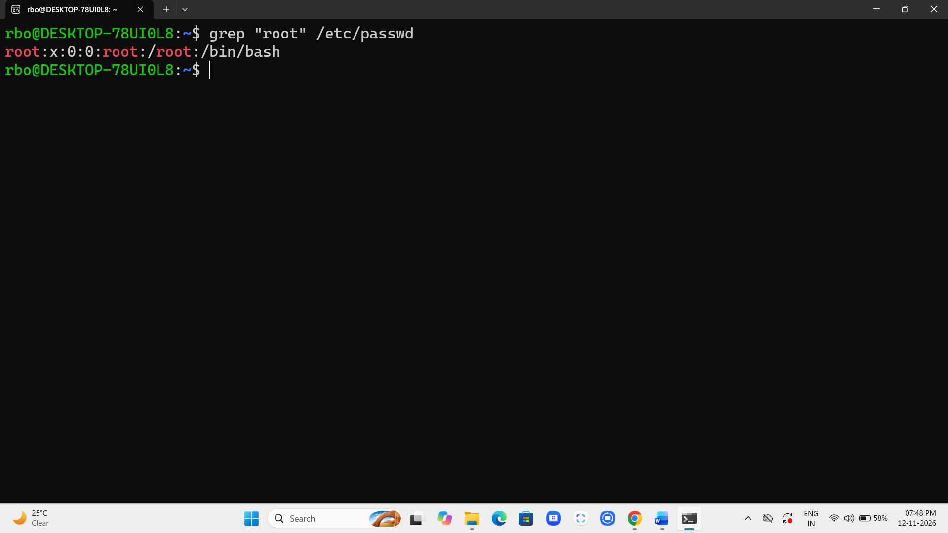

4. Zipping and Unzipping
- Compress the test_dir directory into a file named test_dir.zip using zip.
- Unzip test_dir.zip into a new directory named unzipped_dir.
Commands & Explanation:
1} I compressed the test_dir hierarchy into test_dir.zip by executing zip -r test_dir.zip test_dir. The recursive flag traverses nested subdirectories, encapsulating all constituent file objects within a unified archive.
2} I extracted test_dir.zip into a dedicated folder by executing unzip test_dir.zip -d unzipped_dir. The destination parameter dynamically instantiates the target directory and unpacks the archived hierarchy intact.

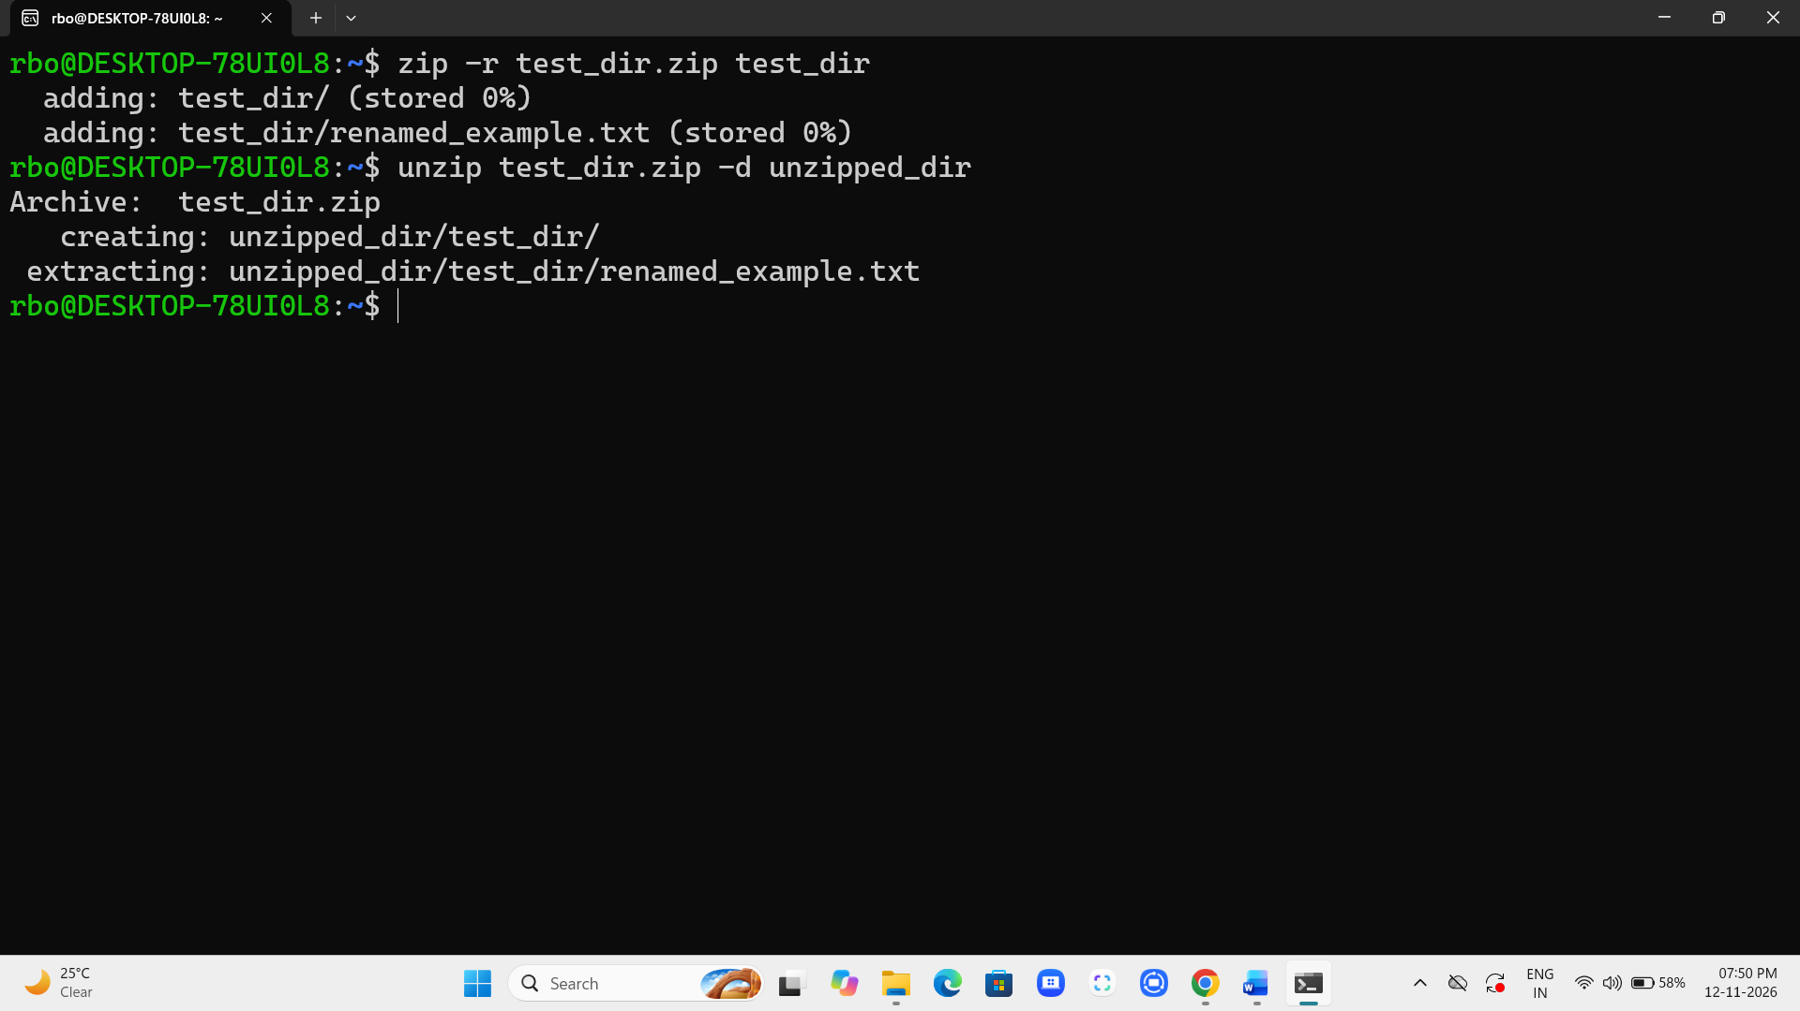

5. Downloading Files
- Use wget to download a file from a URL (e.g., https://example.com/sample.txt).
Commands & Explanation: I retrieved a remote text asset by executing wget https://w3.org. This non-interactive network utility establishes an HTTP connection and writes the downloaded byte stream directly to my local storage.
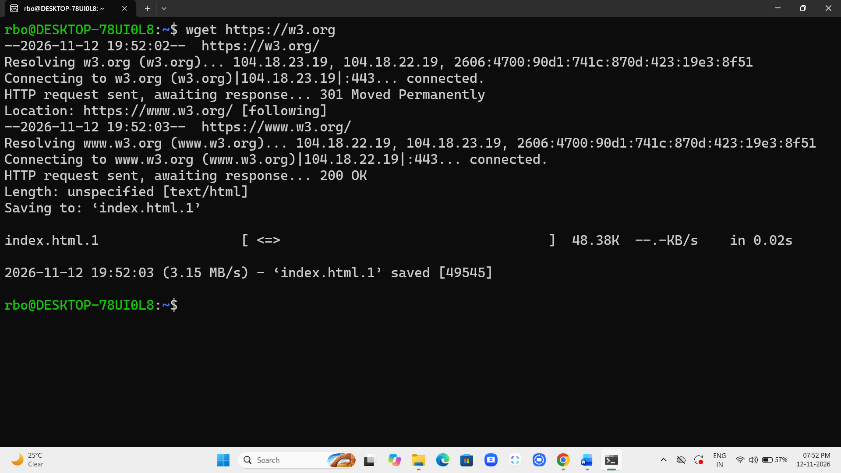

6. Changing Permissions
- Create a file named secure.txt and change its permissions to read-only for everyone using chmod.
Commands & Explanation: I created secure.txt and restricted its access by executing chmod 444 secure.txt. This octal mask revokes write and execute privileges across all user tiers, enforcing universal read-only integrity.

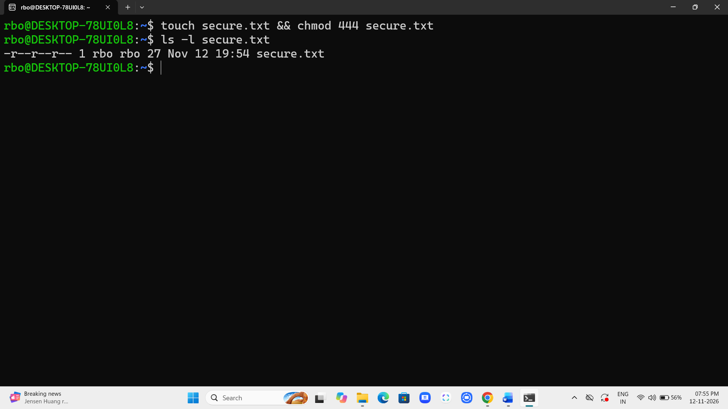

7. Working with Environment Variables
- Use export to set a new environment variable called MY_VAR with the value “Hello, Linux!”.
Commands & Explanation:
I defined a global session variable by executing export MY_VAR="Hello, Linux!". The export builtin registers this key-value pair in shell memory, ensuring automatic inheritance across all spawned child processes.



